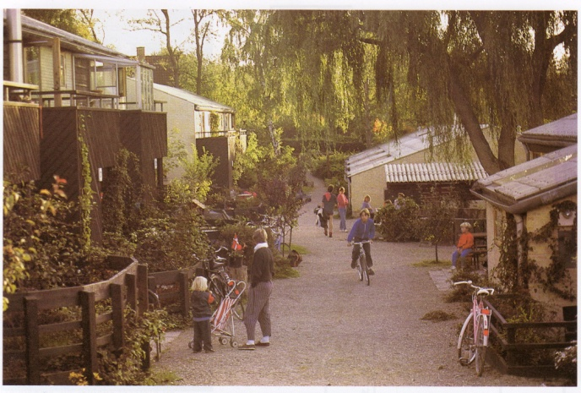  Cohousing reverses the alienating effects of modern life where friendship and collaboration between neighbours is often minimal.    For more information about cohousing, and other projects in the UK, please visit:  www.cohousing.org.uk | KATCH  Information  We meet once a month, alternating between a member’s house and RISC:  RISC  35–39 London Street  Reading  RG1 4PS  Our “home meetings” are also a chance to socialise and have a meal together.  For more information, please visit:  www.KATCH.org.uk  Email. info@katch.org.uk  Or call: 0118 921 2363 |   Kennet And Thames CoHousing  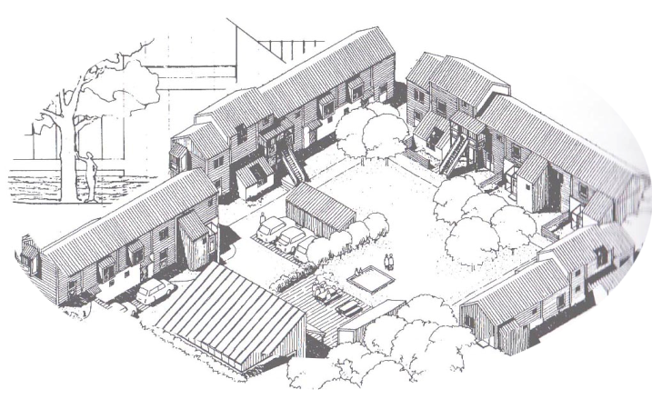  Neighbourhood Development for Community and Independence

What is Cohousing?  Cohousing is a way of living that offers a balance between community and independence. They are neighbourhoods where individuals and families share some common facilities and activities, while enjoying their own self-contained homes.  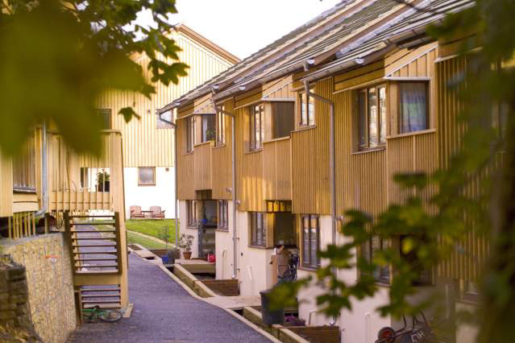  Springhill Cohousing in Stroud  Key features of cohousing  Individual homes and share of communal facilities  Mixed unit development of 20-40 homes  Designed to facilitate interaction, eg pedestrian streets  Neighbourhood managed by residents | 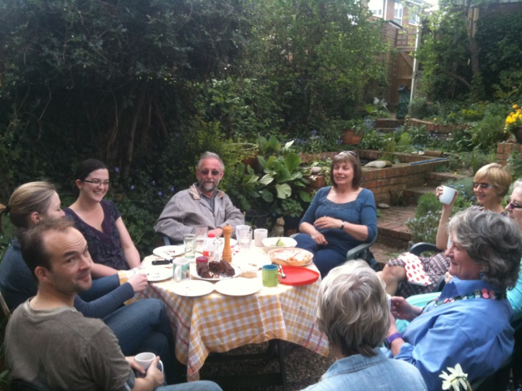  KATCH  Benefits to the surrounding community  Cohousing can bring life, local focus and a neighbourly spirit to an area. The benefits include:  Neighbourly-minded people  Locally focused residents to support local businesses, schools etc  Common facilities which may be used for local events  A few small workshops/business units which provide a local focus  Low-impact neighbourhood, through car pooling, resource sharing etc.  Stimulation of local networks  We hope to find a location where we can bring a positive contribution to the surrounding community. | Our Values  To be supportive and tolerant  To accept diversity and encourage balance  To cultivate community while respecting privacy  To share some resources  To develop an environment-friendly lifestyle  To be part of the wider community  Our Aim  To develop an eco-friendly cohousing neighbourhood in the Thames and Kennet area, focusing on West Berkshire Parish Councils.

